Cadorna, Joeffrey July 11, 2025
BSCS – 1
Long Quiz 2
1.) Translated Java code to Python code:

class Player:
def __init__(self, name, points, three_points, assists, rebounds,
blocks, minutes_played, fouls, turnovers):
self.name = name
self.points = points
self.three_points = three_points
self.assists = assists
self.rebounds = rebounds
self.blocks = blocks
self.minutes_played = minutes_played
self.fouls = fouls
self.turnovers = turnovers

# List of players
team = [
Player("James Harden", 24, 5, 7, 6, 1, 36, 3, 4),
Player("Stephen Curry", 30, 8, 6, 5, 0, 34, 2, 3),
Player("LeBron James", 27, 2, 8, 7, 1, 38, 2, 5),
Player("Kevin Durant", 29, 4, 5, 6, 1, 35, 1, 2),
Player("Giannis Antetokounmpo", 28, 1, 6, 12, 3, 37, 4, 4),
Player("Luka Dončić", 31, 3, 9, 8, 0, 40, 2, 5),
Player("Jayson Tatum", 26, 3, 4, 7, 1, 35, 3, 2),
Player("Nikola Jokić", 25, 1, 10, 11, 2, 38, 3, 3),
Player("Joel Embiid", 30, 0, 4, 10, 2, 37, 2, 3),
Player("Devin Booker", 27, 3, 5, 4, 0, 36, 1, 4)
]

# For initializing the top players with the first player
top_scorer = team[0]
best_rebound = team[0]
best_blocks = team[0]
most_turnovers = team[0]

# Loop
for player in team[1:]:
if player.points > top_scorer.points:
top_scorer = player
if player.rebounds > best_rebound.rebounds:
best_rebound = player
if player.blocks > best_blocks.blocks:
best_blocks = player
if player.turnovers > most_turnovers.turnovers:
most_turnovers = player

# Output
print(f"Top Scorer: {top_scorer.name} with {top_scorer.points} points")
print(f"Best in Rebound: {best_rebound.name} with {best_rebound.rebounds} rebounds")
print(f"Best in Blocks: {best_blocks.name} with {best_blocks.blocks} blocks")
print(f"Most Turnovers: {most_turnovers.name} with {most_turnovers.turnovers} turnovers")
2.) Screenshot of the Program Executed:
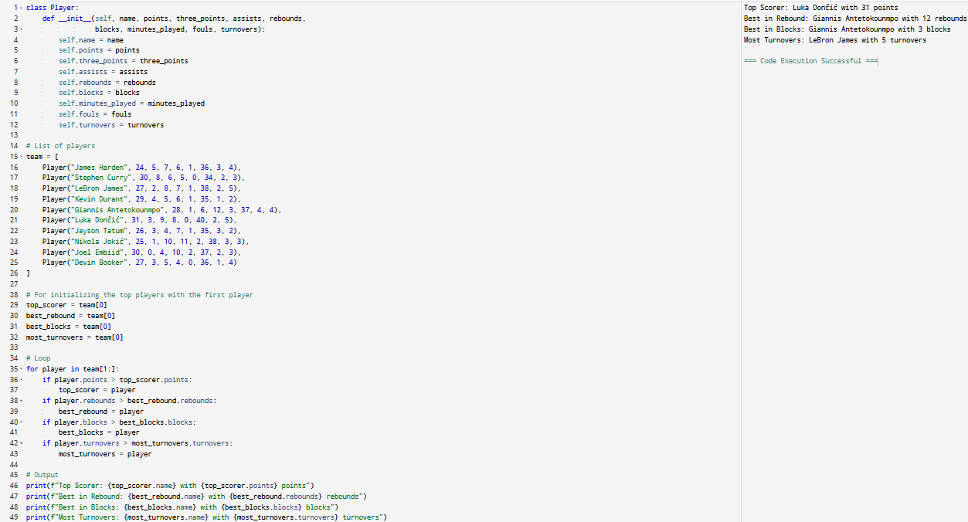
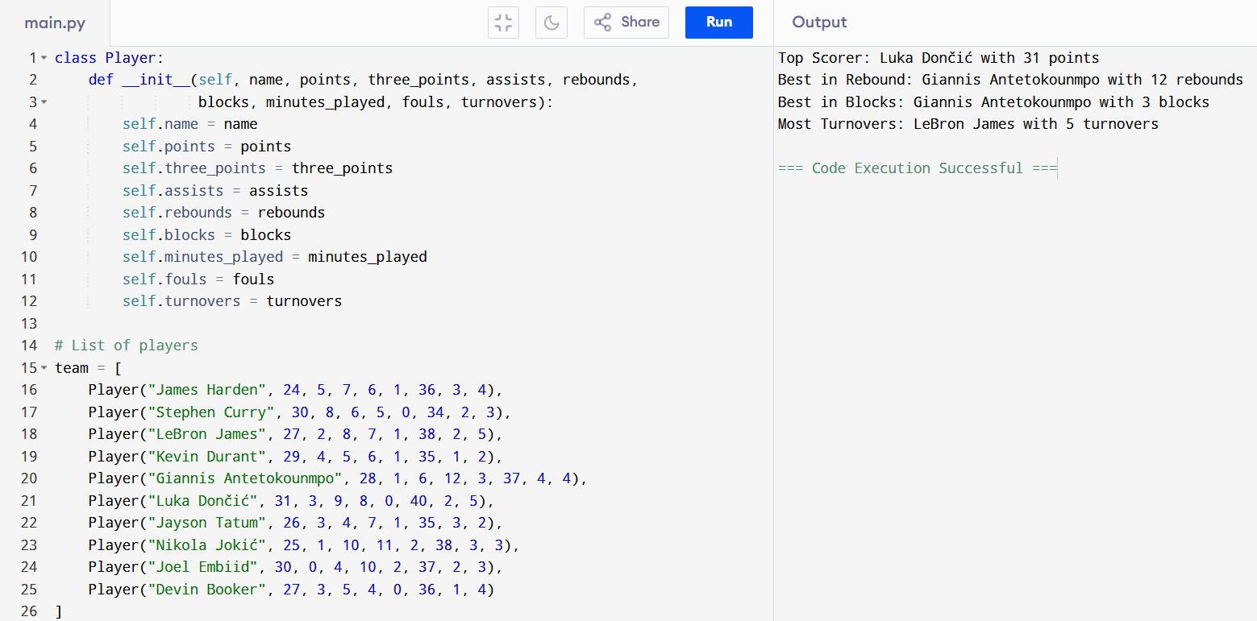
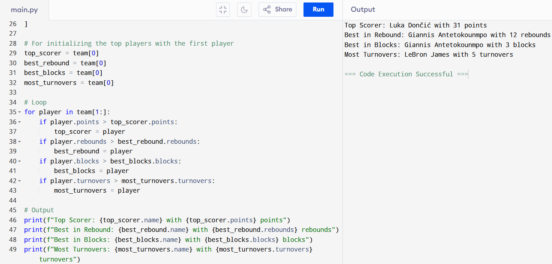

3.) Narrative:
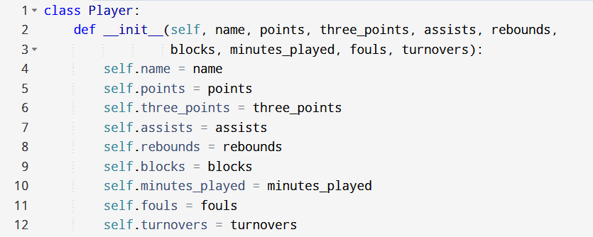
First, I had defined the Player class that represents each of the basketball players. The _init_ method is the constructor of this class, which initializes the player’s stats like their name, points, rebounds, and so on. Then, each parameter becomes an attribute of the player object such as the self.name = name that corresponds to their name, self.fouls = fouls and among others.

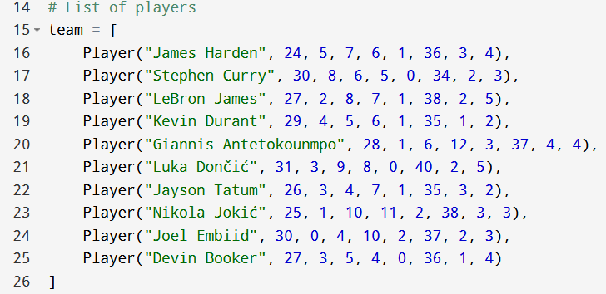
Next, we have the team (or the list of players), where the list (team) stores the 10 Player objects. Where each player is/are created using the Player(“”, , ,…) constructor, thus passing their individual stats.

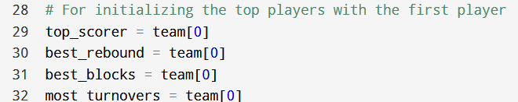
Moreover, I had initialized the stats leaders. Where each of these variables will track the player/s with the highest points, rebounds, blocks, and turnovers. Initially, we assume the first player (team[0]) is the leader in each category or team, which is similar to the previously given activities, where it usually starts at 0 instead of 1.

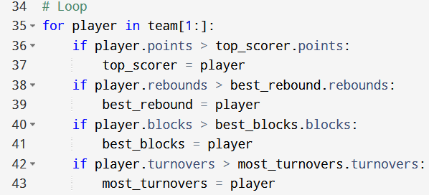
In addition, there is the utilization of an if statements in the loop. Where the program loops through the rest of the players (team[1:]) which means from index 1 to the end). Such that, for each player we get to compare their stats with the current “best or top” player”: If a player has more points, they would then become the new top_scorer and this applies for the player’s other attributes such as rebounds, blocks, and turnovers.

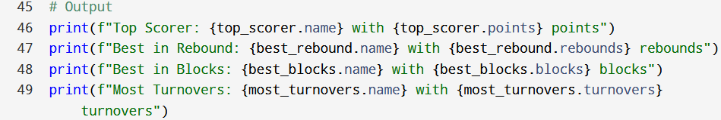
Furthermore, in this section prints the name and stats of the top player in each category such as the top scorer, best rebound, best blocks, and so on. In conjunction with that I have made use of the f”…{value}…” syntax in Python called the f-string (short for formatted string literal), which is used to insert variables or expressions in a string, which makes string formatting somewhat easier and cleaner to look and understand. Where everything inside the {} is evaluated then gets converted into a string.
For example, the print(f"Top Scorer: {top_scorer.name} with {top_scorer.points} points"). The f”… starts the formatted string, then the {top_scorer.name} gets the name of the player with the top scorer such as “Luka Dončić”, and the same applies for the other stats such as in Best in Rebound, Best in Blocks, and amongst others, which then outputs or prints something like this one: “Top Scorer: Luka Dončić with 31 points” instead of using the print(“Top Scorer: “ + top_scorer.name + “ with ” + str(top_scorer.points) + “ points”) which is a bit longer and harder to read, hence why the usage of the f-string.

